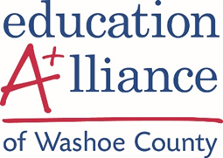

P-16 Advocacy Council Meeting Dates 2018 - 2019

Purpose: To advocate for a seamless educational system that helps all students successfully achieve their career and life goals.

All meetings held the 3rd Friday of the month at 7:30 AM and held at
UNR InNevation Center, 450 Sinclair Str., Reno unless otherwise noted*
SUBJECT TO CHANGE

Friday, August 17, 2018

Friday, September 21, 2018

Friday, October 19, 2018

Friday, November 16, 2018

December - Dark

Friday, January 18, 2019

Friday, February 15, 2019

Friday, March 15, 2019

Friday, April 19, 2019

Friday, May 10, 2019

June and July - dark

