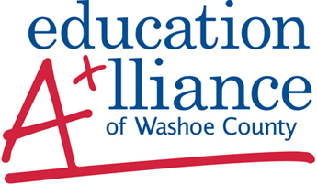

The Education Alliance is a community partnership with programs that support academic achievement and workforce development for pre-school to college students (P-16).

Our Mission is to foster educational excellence and student achievement in Washoe County through leadership, advocacy, and resource development. The Education Alliance works with many diverse state, city, community, civic, industry, and business groups in support of education, including The Chamber, EDAWN, the Nell J. Redfield Foundation, local Rotary Clubs, among many others. These efforts are directed at initiatives that bring education and businesses/community organizations together.

Education Alliance’s governing Board is comprised of 30 dynamic business, community, and education leaders. Three permanent board members include the WCSD Superintendent, and the Presidents of the University of Nevada, Reno, and Truckee Meadows Community College. As a 501(c)3 nonprofit organization, we rely on funding from charitable donations, grants, and support from the Washoe County School District, a long-standing relationship of more than 20 years.

The focus of the Education Alliance is to help all students succeed. Successful students are ready for higher education and career opportunities and our community benefits from a more skilled and educated workforce.

Education Alliance programs, initiatives, and structures provide a link between business, community, and schools and include:

- P-16 Advocacy Council
- Career and College Readiness Initiative
- Production of the annual K-16 Data Profile
- Partners in Education
- Run For Education Annual Fundraising Event, October 23, 2016
- Principal/Executive for a Day annually, September 22, 2016
- Teachers’ Warehouse
- Redfield Community Outreach Program

Please join us in supporting students in our community!
Kendall Inskip, Executive Director
kinskip@washoeschools.net
Sean McCaffrey, Collaborative Coordinator
smccaffrey@washoeschools.net
Kelli Pennington, Administrative Assistant
kpennington@washoeshools.net
425 East Ninth Street, Reno, NV 89512
Phone: 775-353-6950 • Fax: 775-353-5536 • www.ed-alliance.org

